Prometheus install
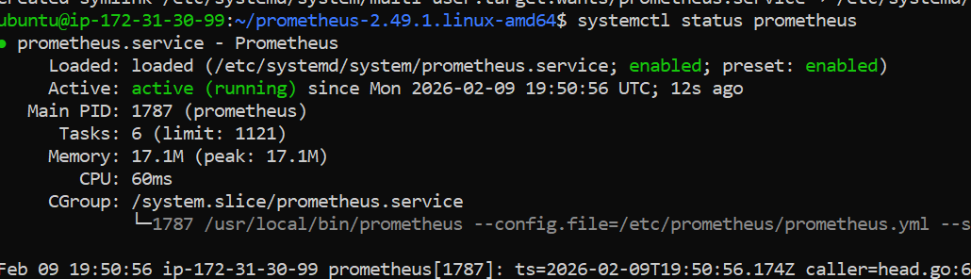

Grafana install
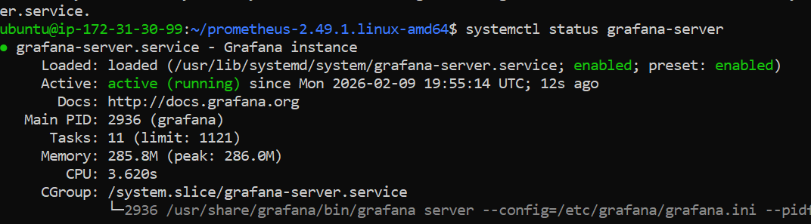

Accessed via web page
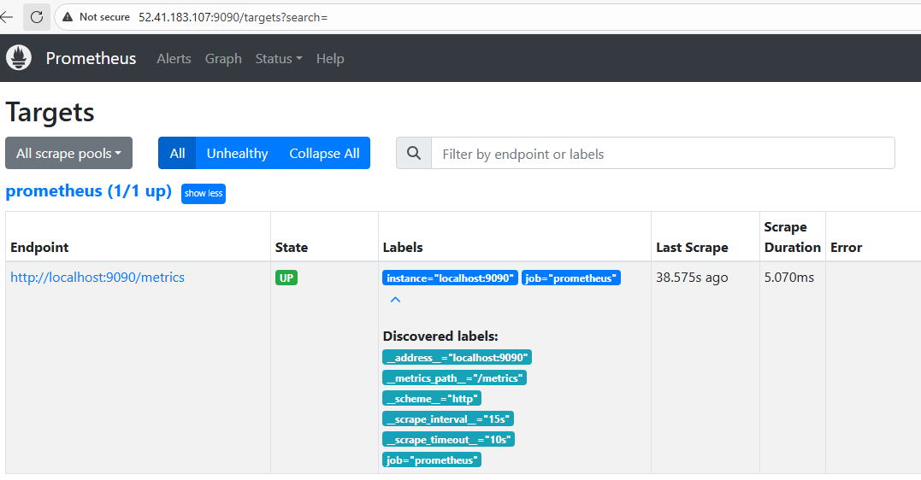

Grafana Dashbord which is monitoring the host where both are installed

